**Difference between shared, dedicated instances and dedicated hosts in AWS:**

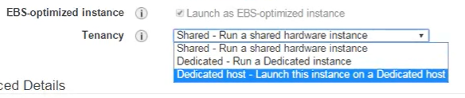

* We can see the above options while creating the EC2 instance and we can select based on our requirement.

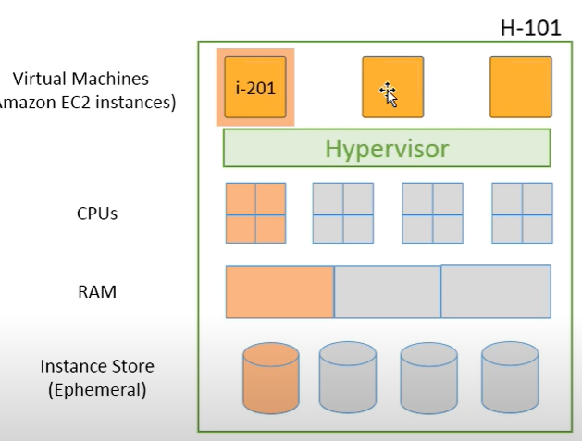

* Shared tenancy means the multiple customers can share the same physical device.
* As above, let’s say i-201 is a physical box, it can be shared by multiple customers to launch the instances.
* And if we restart the instance, next time the instance might get started using another physical device. But not the same one every time.
* This is the same for dedicated instances as well, the underlying hardware might get changes when we restart the instances. But the underlying physical will not be shared with any other instance. Not even by the instance if you launch with share tenancy from same account.
* But with dedicated hosts, even if we restart the instance, the underlying physical device won’t get changes. It will be the same.
* If we are having any application where there are any CPU or hardware bound licences, then this method will be helpful to not change them even we restart the server.
* Dedicated host is the costliest one.